How can decision of shooting location according to astrology change the fate of the movie?

Meta Description: AstroKapoor helps in finalising the set of the movie both indoors and outdoors. Lean all about it.

<h2> Movie Set/ Location Finalisation </h2>
AstroKapoor provides a service that finalises movie sets and shooting sites.
In the film industry, massive investments are at play. The careers of many individuals are at stake during the movie shoot. Therefore, every decision has to be taken, considering all these factors. Astrology, especially Vedic astrology, has always been considered a guiding science that helps individuals make the right choices at the right time. This service by AstroKapoor helps individuals select the right location and set for their shoot.

<h2> How we Assist in Movie Set Finalisation? </h2>
AstroKapoor has an expert panel that advises producers and directors with the locations, both indoors and outdoors.
During the process, AstroKapoor conducts a horoscope analysis of the producers, directors, lead actors, etc. The current planetary positions as well as the planetary positions at the time of birth is also considered. The dashas and transits are also analysed. These factors help determine which directions, locations, and environments will bring maximum success and which ones should be avoided.
There are way too many conflicts while shooting the project and even post shooting. As per Vedic astrology, most of these is due to the astrological factors not favouring the project. Maybe the project was shot during an unfavourable period or maybe the shoot location was not compatible with the birth charts. The consultation aims to minimize such risks by aligning the shooting environment with favorable cosmic energies.

<h2> Directional Influence on Movie Sets </h2>
As per Vedic Astrology, every person has an auspicious direction mentioned in the birth chart. When this particular direction is chosedn for shooting the movie, it increases the probability of success.
For example, some individuals get maximum success when working towards the east, while others achieve better results when facing north, west, or south. These directions are calculated using the ascendant (lagna), moon sign, and planetary strength in the horoscope.
A film set designed taking these directions into consideration becomes more balanced astrologically. There is better coordination between the members of the film, smoother shooting procedure, and the attention is towards making the film better rather than resolving daily issues of the set. This is also known as directional astrology.
Directional astrology also has connections with Vastu Shastra, the ancient science of architecture. Vastu Shastra has been practiced by Indians since a long time. Now, filmmakers and producers have also taken notice of this ancient science and adapted it to their sets.
This combination of directional astrology and Vastu Shastra is a lethal one and can seriously increase the probability of the movie turning into a successful one.

<h2> Fixed Movie sets: Astrological Adjustments </h2>
If the movie sets are fixed and the producers have approached AstroKapoor after the finalisation of the sets, the following adjustments are made, if the producer is not willing to change the location. The key considerations include:
- <h3> Main Entrance Placement <h3>: The main entrance is considered extremely important in vastu and astrology because it is the point from where energy enters the set. If the entrance is placed in an unfavorable direction, it can cause delays, financial stress, or creative conflicts. By identifying the most favorable direction according to the natal charts, we recommend the best possible entrance placement.

- <h3> Position of Main Cast and Make up rooms </h3>: The position of the make-up rooms, vanity vans, editing rooms, and production offices also plays a role in the success of the project. When these are aligned with favorable directions, the workflow becomes smoother and the team experiences less stress during the shoot.

- <h3> Logistics Layout </h3>: The logistics layout is also altered a bit to ensure smooth shooting process.

<h2> Outdoor Shooting Locations </h2>
AstroKapoor provides a detailed plan on the outdoor locations, based on the geographical directionality. The geographical direction is analysed from the birthplace of the producer or director. According to Vedic astrology, traveling or working in certain directions during specific planetary periods can bring success, while other directions may lead to obstacles.This method has been used since decades in business astrology, however, it has now begun in entertainment vastu too.
The muhurat to commence the shooting at a new location is also decided by AstroKapoor. The date is considered after taking into consideration the transits, dashas, planetary placements, etc.

<h2> Why Choose AstroKapoor? </h2>
AstroKapoor’s detailed consultation ensures a positive and smooth shooting atmosphere.
Years of experience in dealing with various filmmakers across mediums has helped AstroKapoor in being the best bet while choosing a location. Their approach combines traditional Vedic astrology, vastu shastra, numerology, and practical industry experience.
Many filmmakers believe that only the content and right marketing would not guarantee success. One needs the right timing and right direction also to ensure success. By taking astrological guidance before finalizing movie sets and locations, they are able to avoid mistakes that could otherwise cost crores of rupees.
AstroKapoor ensures complete confidentiality and privacy while providing the consultation. Each consultation is personalised. Also, since each project is separate, the guidance and the consultation is also individualised.

<h2> Consultation details </h2>
This service is a value added service. The process is meticulous and time-consuming but yields the best results. Consultation will be given by Mr. Prashant Kapoor.
Mr. Prashant Kapoor is a renowned astrologer and the Founder of AstroKapoor. His experience in guiding business owners, celebrities, and filmmakers has helped many people achieve success through the correct use of astrological remedies and directional alignment.
AstroKapoor with the help of Vastu and directional astrology will ensure a smooth shooting time of the project. This would directly have an effect on the release and success of the movie. Filmmakers can take a huge advantage of this service of AstroKapoor and seal the fate of their movie.

<h2> Horoscope Analysis </h2>
AstroKapoor is dedicated to providing detailed astrology consultations. Our astrology services include:
• Astrology Gemstones
• Kundali Matching for Marriage
• Birth Chart Analysis
• Horoscope Analysis
And many more….
Our astrology services are a comprehensive package that covers all aspects of a human life. Book your consultation now!

Duplichecker
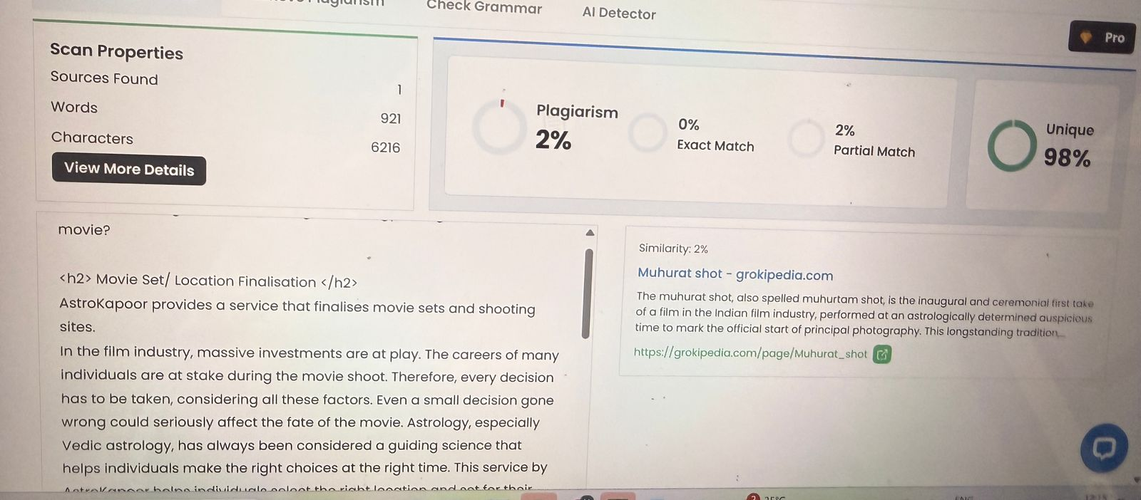

Zerogpt
